LAUNCH YOUR CAREER IN JUST 12 WEEKS AS A

Heavy Duty Transit Mechanic
Pre-Apprenticeship Training with the Detroit Department of Transportation

Just
16 students per class.
Sign up early!
Additional sections may be offered if demand is high.

Hands-on experience. Real equipment.
Real opportunity.

Starting Dates
First session: March 23, 2026
Second session: July 13, 2026 Monday - Friday (12 Weeks) 8:00 a.m. - 1:00 p.m.
Henry Ford College | Main Campus
Tuition is free for qualified applicants.
Textbooks are included.
Train for a career that moves Detroit.
Henry Ford College and the Detroit Department of Transportation (DDOT) are partnering to prepare the next generation of heavy-duty transit mechanics. In just three months, this hands-on training program prepares you for a job working on DDOT buses and other heavy-duty diesel equipment. The skills are transferable to other heavy-duty equipment suppliers.

Recognized with a MARC Level II Endorsement, this program meets high-quality standards for apprenticeship readiness in Michigan.

What you will gain
- Hands-on training with DDOT buses
- Industry-recognized preparation
- Direct pathway to employment opportunities; transferable skills

Screening Requirements
To qualify, you must:
- Have a high school diploma or GED
- Be CDA-B eligible (this is required to obtain the necessary CDL permit)
- Have a valid Michigan driver’s license with a satisfactory motor vehicle record
- Have some mechanical experience
- Pass all required pre-employment screenings, including:
  - Criminal background check
  - FT A-compliant drug screen (no drugs in your system)
  - Physical examination
  - Motor vehicle record review

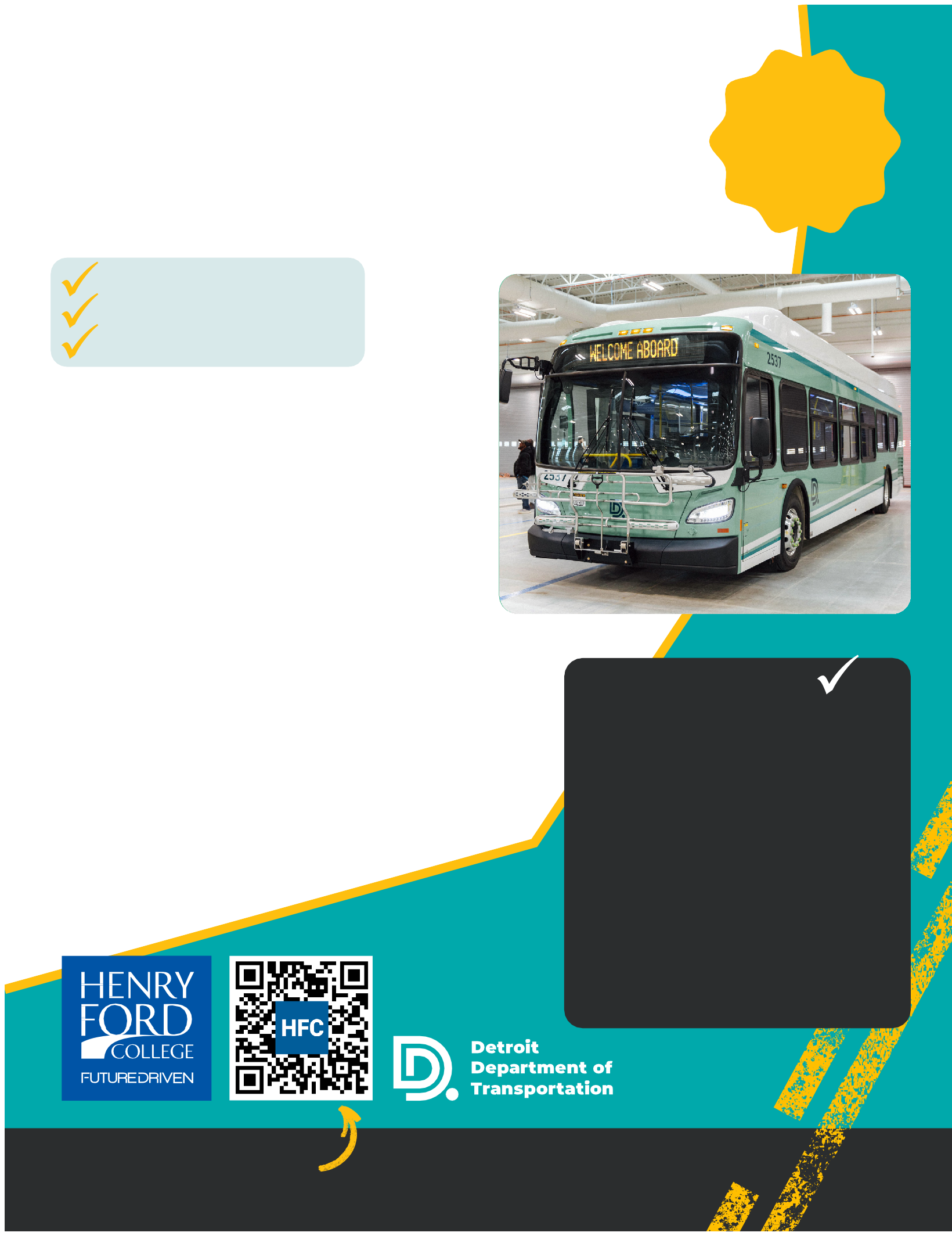

Apply Today: hfcc.edu/apply
Scan the QR code to apply through Henry Ford College

